
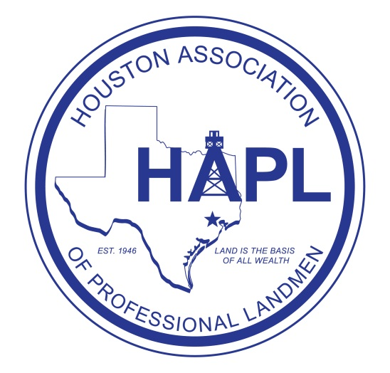

Sponsor Levels:

Silver Level sponsor: $250+
- Recognition at event on sponsor banner
- Recognition on HAPL website and Newsletter

Gold Level sponsor: $500+
- All perks of Silver Level sponsor
- Recognition on HAPL event reminder emails

Platinum Level Sponsor: $1000+
- All perks of Gold Level Sponsor
- Ability to provide company gift items and/or a reasonably sized company banner to display at event

Sponsor Information

Company Name to Display

Contact Name

Contact Phone Number

Contact Email

Send a check made out to HAPL and this form to:

ATTN: Matt Bruns
EP Energy E&P Company, L.P.
1001 Louisiana St. Suite 2775D
Houston, TX 77002

Contact Matt Bruns at 713-997-3205 or Matthew.Bruns@EPEnergy.com for questions

