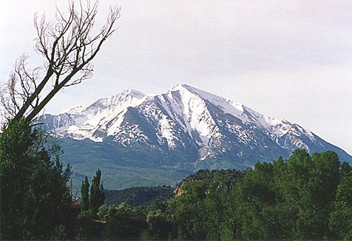
YOU ARE INVITED TO ATTEND

The 16th Annual
“ROCKIES RENDEZVOUS”
SOCIAL

PRESENTED BY

THE HOUSTON ASSOCIATION OF PROFESSIONAL LANDMEN

WHAT: HAPPY HOUR WITH A MEXICAN FLAIR
Food and Refreshments provided

WHEN: TUESDAY, APRIL 12, 2016
5:30 P.M. to 7:30 P.M.

WHERE: ST. ARNOLD’S BREWERY (Main Hall)
2000 LYONS AVENUE
HOUSTON, TEXAS 77020

WHY: A ROCKIES RENDEZVOUS FOR LANDMEN
TO COLLABORATE, BARTER, AND
SPIN STORIES ON LATEST DISCOVERIES
Levels of sponsorship:
o Gold: $1000 and above
o Silver: $500
o Bronze: $250
o Other: Donation items, Door Prizes, Trips, etc.

Sponsor Information: Make Checks Payable To:

Company _____________________ HAPL

Address: ______________________ C/O Mark Taylor Metz
Representative: ________________ 400 Emerson St.
Amount: ______________________ Houston, TX 77006
Phone: _______________________ (832) 526-2400
e-mail: _______________________

