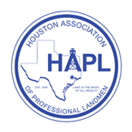

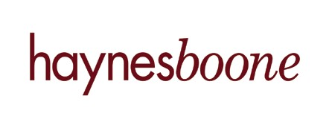
47th Annual HAPL Technical Workshop
Agenda

Time | Topic | Speaker | Company
8:00-8:05 | Opening Remarks & Introduction | Amanda L. Van Deusen, CPL | Landman at Haynes and Boone, LLP
8:05-8:50 | New Revisions to the AAPL Form 610 JOA | Jeff Weems | Partner at Staff Weems LLP
9:00-9:50 | Oil & Gas Lease Mechanics and Timing | Kristyn Weaver | Attorney/Landman at Kristyn Weaver Law Firm, PLLC
10:00-10:50 | Title Due Diligence for E&P Financing Transactions – Role of the Landman | Randy Browne, CPL | Landman at Haynes and Boone, LLP
11:00-11:50 | A&D Integration – Post-Close Review & Isolating Special Assets | Jayne Iffla, CPL | Senior Staff Landman at Linn Energy
12:00-12:30 | Lunch Break
12:30-1:20 | Declining Oil Prices, Asset Sales & Bankruptcy - What It Means To You? ate | Charles A. Beckham, Jr. | Partner at Haynes and Boone, LLP
1:30-2:20 | Idiosyncratic Language in Multi-State Title Instruments | M. Ryan Kirby | Partner at Kirby, Mathews & Walrath, PLLC
2:30-3:30 | Ethics in Negotiations - From the Landman’s Perspective (Landmen Do's & Don'ts) | Gregory L. Jessup, CPL | CEO of Jessup Harper Dean LLC

2016 Haynes and Boone, LLP

