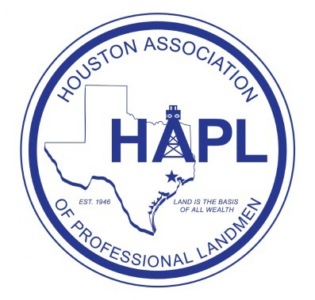

Sponsor the 2016 Shale Play Seminar and Social!

Thursday, September 29th, 2016

**** ALL SHALE PLAYS ****
(Permian Basin Shales, Eagle Ford, Bakken, Niobrara, Marcellus, Haynesville, Fayetteville, Barnett, Woodford and more)

The Houston Association of Professional Landmen (HAPL) Shale Play Seminar and the Shale Play Social will be held Thursday, September 29th, 2016 in Highland Village at Smith and Wollensky, 4007 Westheimer Rd., Houston, Texas, 77027. The social is an informal networking event in Houston dedicated to those individuals and companies that work in or have an interest in shale plays. The HAPL Shale Play Social proved to be a very successful networking event for shale players last year - there were hundreds in attendance! This event is only made possible by our generous sponsors. Our goal is to make this year’s HAPL Shale Play Social an even greater networking success. The Social will be held on the entire second floor of Smith and Wollensky.

We are currently looking for sponsors. The Shale Play Seminar and the Shale Play Social committees work together and pool our fundraising. If your organization is interested in being a sponsor for these events, please contact Jonathan Click (see next page). Your company will be recognized prominently with signage at t he seminar and the social in addition to applicable sponsor level benefits described below:

Sponsor Levels:

Platinum Level Sponsor - $1,000+
All the benefits of Gold Sponsorship AND the ability to provide company gift items and/or a reasonably sized company banner to display at the social.

Gold Level Sponsor - $750+
Recognition at the events on the sponsor poster AND in the Newsletter.

Silver Level Sponsor - $500+
Recognition at the events on the sponsor poster AND in the Newsletter.

Bronze Level Sponsor - $250+
Recognition at the events on the sponsor poster.

Landman Level Sponsor - $100+
Recognition at the events on the sponsor poster.

Page 1 of 2

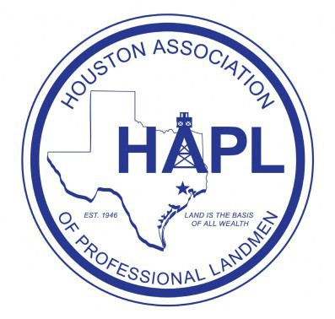

COMPLETE AND RETURN:

Thank you in advance for helping us to continue to make this event one of HAPL's premier socials.
We look forward to seeing you there!

2016 Shale Play Seminar and Social Sponsor Form

Please complete and email this form to a Chairman. Include a copy if you pay by check.

Name of Business/Organization:

Contact Name:
Phone:

Address:

Email:

Requested Sponsor Level (first come, first served):

Comments:

Make checks payable to “HAPL” and write “Shale Play” and your chosen Sponsor Level in the Memo section. Mail your check to HAPL at 800 Bering Drive, Suite 120, Houston, Texas 77057
Be sure to email your company’s name/Logo as you would like it to appear on the sponsor board to Jonathan Click NO LATER THAN September 26th, 2015.

Jonathan Click, CPL

Shale Play Seminar & Social Chairman
Jonathanclick@gmail.com
(832) 725-9910

Page 2 of 2

